Things needed in each class

Parent Class: Character

Will be fully virtual.

Contains all things necessary to create the derived classes.

Functions necessary

* Attack
* Defense
* Damage taken
* Alive
* Getters and setters for stats of the characters

Derived Class: Reptile

All the functions found in character will be defined for the Reptile class.

Derived Class: Blue Men

The Blue men will be laid out the same as Reptile. The Blue men will lose a dice roll every four damage taken.

Derived Class: Medusa

The Medusa will be laid out the same as Reptile. Medusa’s special is if she rolls a max she wins instantly.

Derived Class: Gollum

The Gollum will be laid out the same as Reptile. Gollum has a five percent chance of rolling 3 dice for attack instead of 1.

Derived Class: HarryPotter

The Harry Potter will be laid out the same as Reptile. Harry Potter has 10 health but goes back up to full after losing all of his health for the first time. (Medusa’s glare overrides Harry Potter’s skill.

Class: Dice

The dice class will control all of the random number rolling in the game.

Main:

List the five characters that can be chosen. Allow for both players to choose the same character.

The player who will go first will be determined by a dice roll with tie going to player 1. Since

each character takes turn fighting there can be no tie.

Included on the next two pages is a rough outline for the basic flow of the program.

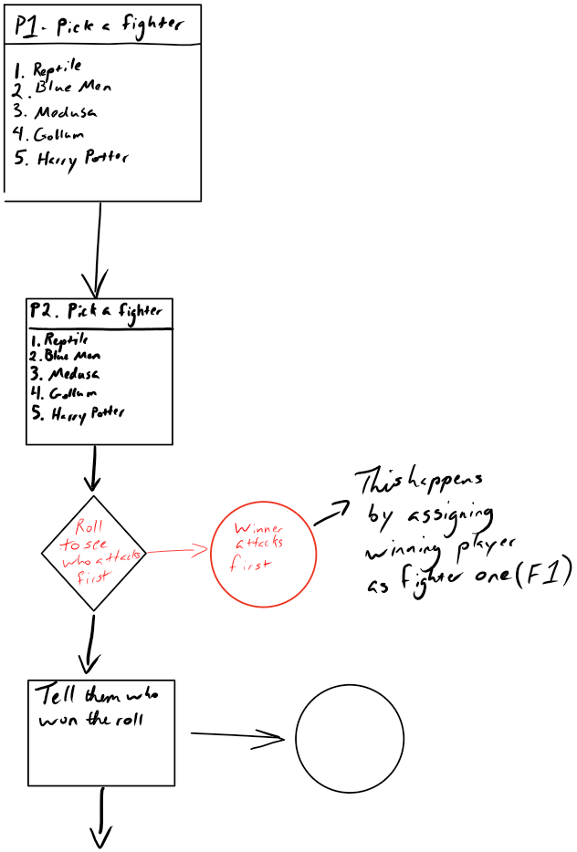

Cout Player _ won the roll and will attach first

